***Design (GUI, UML diagrams)***

***Activity Diagrams:***

**Activity- Mellanox Care Daily report**

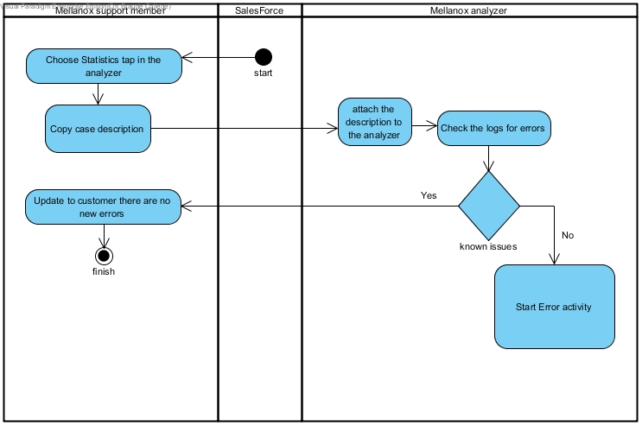

**Activity - Handle Error**

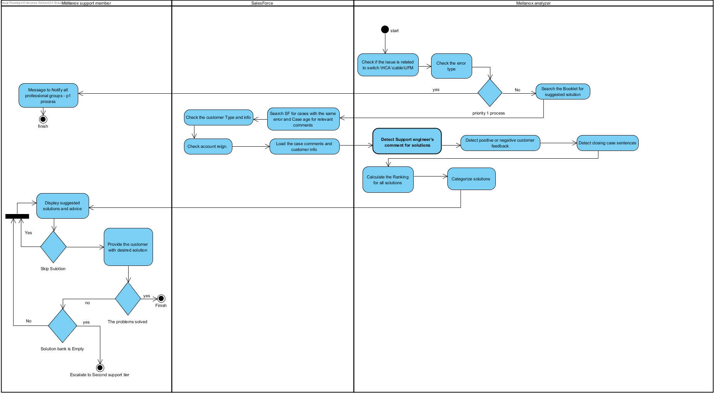

**Activity - Mellanox Care Keep alive event:**



**Activity- Show statistics**

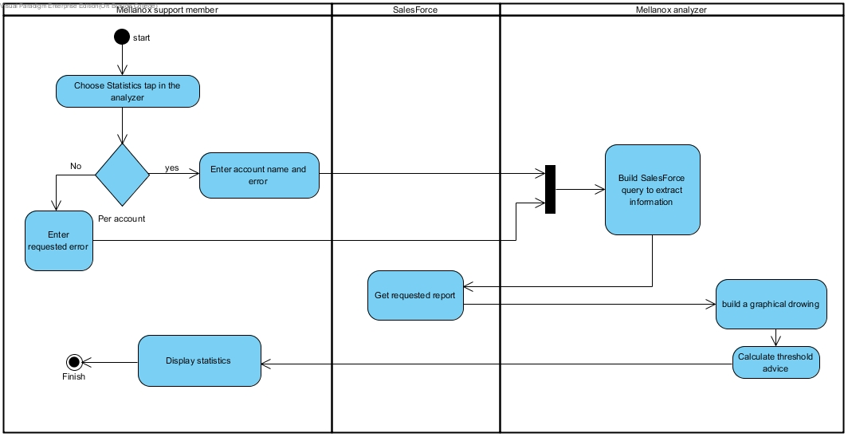

**Class Diagram:**

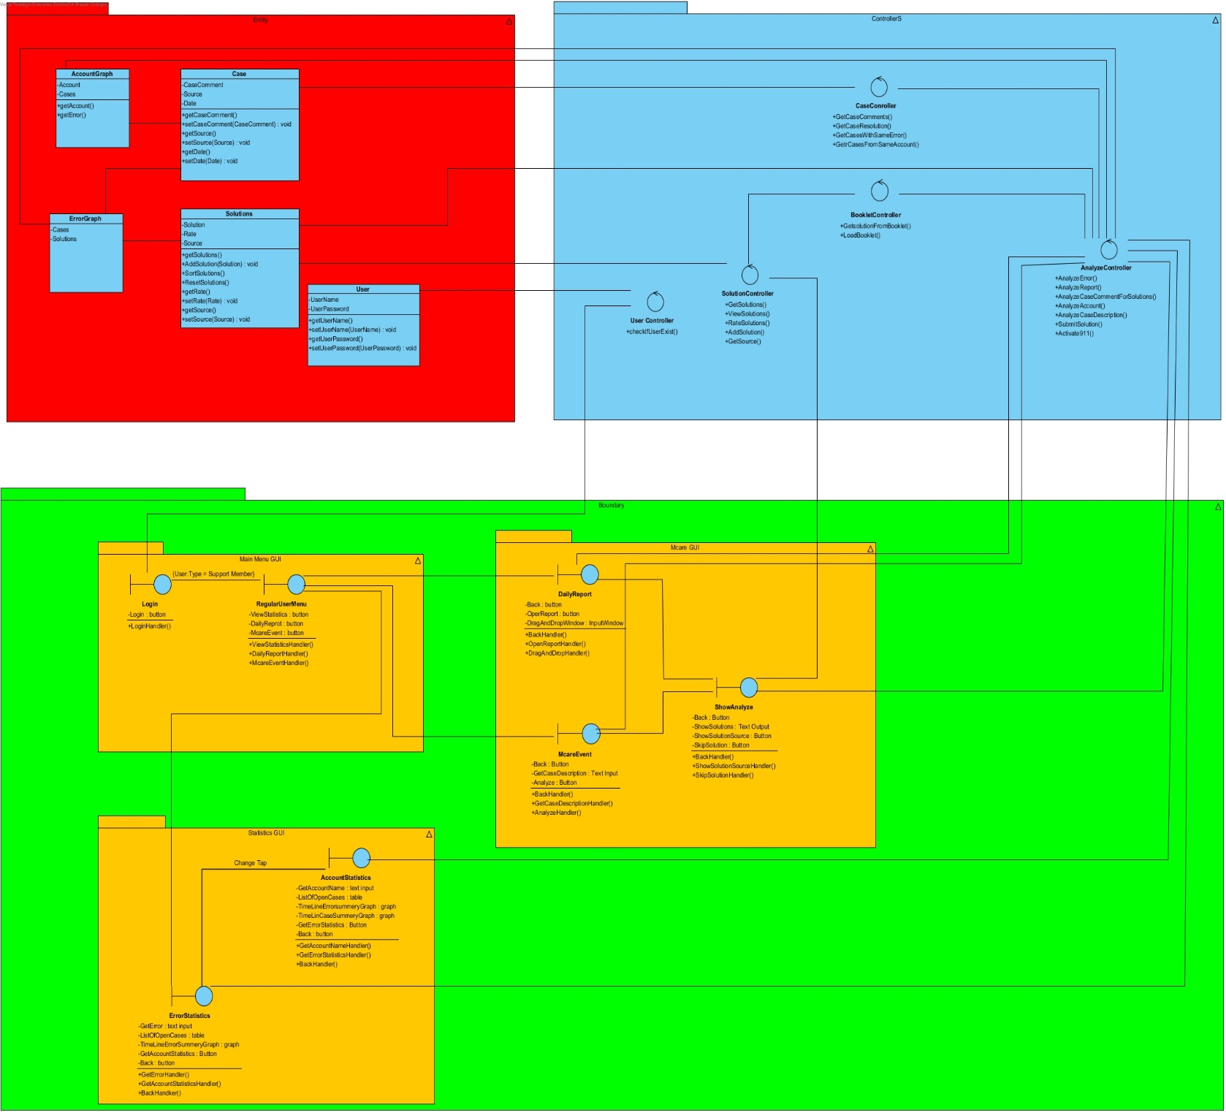

**Data Flow Diagram:**

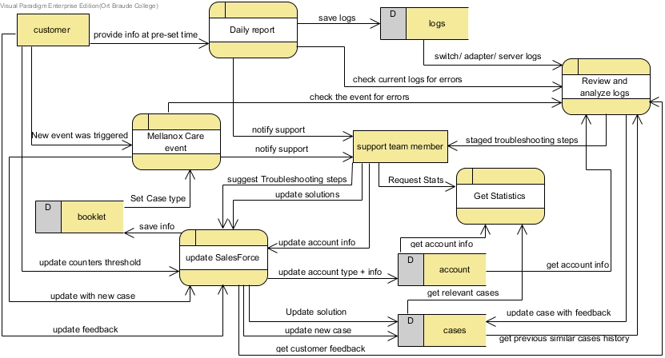

**Connection Diagram:** 